**SQL QUERIES EXAMPLE**

SQL is Structured Query Language, which is a computer language for storing, manipulating and retrieving data stored in a relational database.

**Creating Database**

create database db1;

**Use Database**

use db1;

**creating Employee Table**

create table Employee (

Emp_ID int,

Emp_Name varchar(45),

Emp_Age int,

Emp_Dept varchar(45),

Dept_ID int,

Emp_Location varchar(45)

);

**Inserting Values to Employee Table**

insert into Employee(Emp_ID,Emp_Name,Emp_Age,Emp_Dept,Dept_ID,Emp_Location) values('101','jomin','22','IT','111','Bangalore');

insert into Employee(Emp_ID,Emp_Name,Emp_Age,Emp_Dept,Dept_ID,Emp_Location) values('102','kiran','23','Sales','111','Chennai');

insert into Employee(Emp_ID,Emp_Name,Emp_Age,Emp_Dept,Dept_ID,Emp_Location) values('103','swetha','30','HR','111','Hyderabad');

**creating Department Table**

create table Department (

Dept_ID int,

Dept_Name varchar(45),

Dept_Location varchar(45),

Project_ID int );

**Inserting values to Department Table**

insert into Department(Dept_ID,Dept_Name,Dept_Location,Project_ID) values('111','HR','Bangalore','11');

insert into Department(Dept_ID,Dept_Name,Dept_Location,Project_ID) values('112','IT','Chennai','12');

insert into Department(Dept_ID,Dept_Name,Dept_Location,Project_ID) values('113','Sales','Pune','15');

**creating Project Table**

create table Project (

ID_Project int,

Project_Name varchar(45),

Project_Location varchar(45),

Project_Strength int );

**Inserting values to Project Table**

insert into Project (ID_Project,Project_Name,Project_Location,Project_Strength) values('11','Health_care','Bangalore','5');

insert into Project (ID_Project,Project_Name,Project_Location,Project_Strength) values('12','Epay','Chennai','6');

insert into Project (ID_Project,Project_Name,Project_Location,Project_Strength) values('13','Stats','Hyderabad','3');

**select * from Employee;**

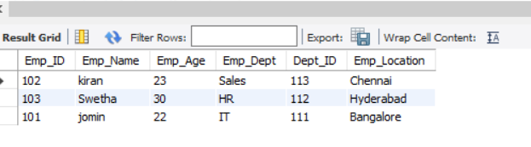

**select * from Department;**

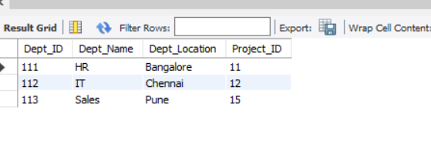

**select * from Project;** 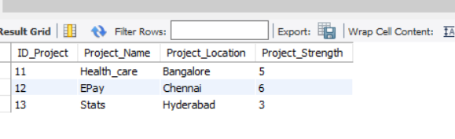

**alter table Employee add Salary double;**

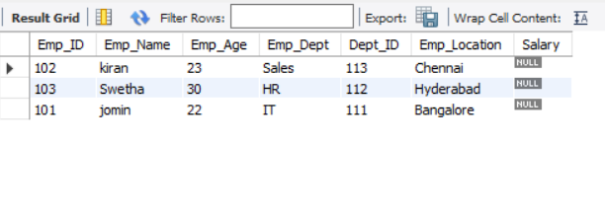UPDATE Employee

SET Salary= '20000'

WHERE Emp_ID = 101;

UPDATE Employee

SET Salary= '10000'

WHERE Emp_ID = 102;

UPDATE Employee

SET Salary= '25000'

WHERE Emp_ID = 103;

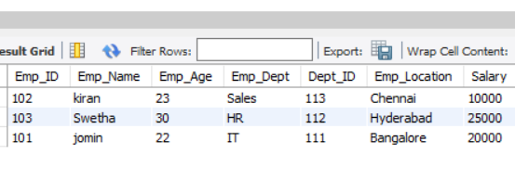 **select Emp_ID,Emp_Name from Employee where Emp_Age>21;**

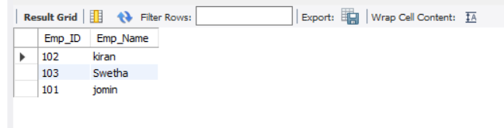

SELECT Emp_Name,Emp_Age

FROM Employee

ORDER BY Emp_Age desc;

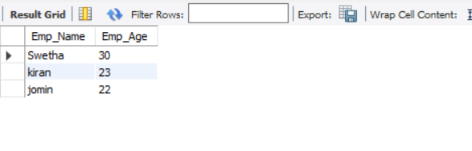

Inner Join

Select Employee.Emp_ID,Employee.Emp_Name,Department.Dept_Name,Department.Dept_Location

from Employee

inner join Department

on Employee.Dept_ID=Department.Dept_ID;

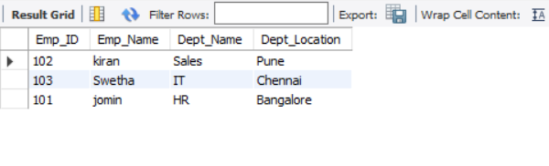

Left Join

select Employee.Emp_Name,Employee.Emp_Age,Project.Project_Name,Project.Project_Location

from Employee

left join Project

on Employee.Emp_Location=Project.Project_Location;

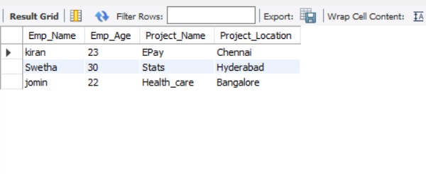

Right Join

select Employee.Emp_Name,Employee.Emp_Dept,Department.Dept_Name

from Employee

right join Department

on Employee.Emp_Location=Department.Dept_Location;

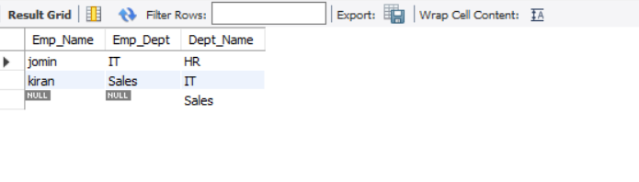

Cross Join

select * from Project cross join Department where Project_Strength>3;

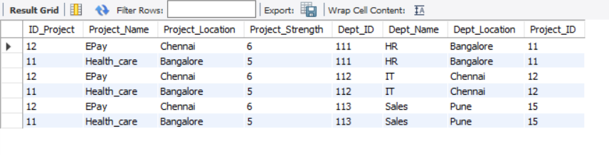

**Store Procedures**

CREATE DEFINER=`root`@`localhost` PROCEDURE `Update Salary`(in New_Salary double, in New_ID int)

BEGIN

update Employee set Salary=New_Salary where Emp_ID=New_ID;

END

call db1.`Update Salary`(45000, 103);

